Division with Remainders
Subject: Mathematics Creator: Alison Kimbley
Strand: Number Grade: 4
Content (topic)

Exploring More Products
Outcomes  N 4.5: Demonstrate an understanding of division (1-digit divisor and p to 2-digit dividend) to solve problems by:  - Using personal strategies for dividing, with and without concrete materials  - Estimating quotients  - Solving problems involving division of whole numbers  - Relating division to multiplication | Indicators  N 4.5 a: Solve a division problem without a remainder using arrays or base ten materials.  N 4.5b: Solve a division problem with a remainder using arrays or base ten materials  N 4.5c: Solve a division problem using a personal strategy and record the process symbolically.
Mathematical Processes:
- Communication
- Connections
- Problem Solving
- Mental Mathematics and Estimation
- Reasoning
- Visualization
Lesson Preparation
Equipment/materials:
- One centimeter graph paper
- A loom
- A set of pony beads
- Wool
- Markers/pencil crayons
Advanced Preparation:
- *Instructions for making a loom*
- Learn how to bead the loom.
Presentation
Development
- Teach the students about the significance of beads. For example, beading has been an important part of First Nations culture for approximately 8 000 years prior to European contact. Beads were made of shell, pearl, bone, teeth, stone, and fossil stems. Glass beads became a part of First Nation and Métis culture when the explorers came from Europe and brought seed and glass beads as trading items.
- Explain to students that each tribe had distinct designs, patterns, and approaches; therefore, collections of First Nations beadwork art includes many different designs, styles, traditions and stitches. In Saskatchewan, the Plains Cree People use a lot of symmetry in their patterns as well as distinctive geometrical shapes.
- Have the students use four columns of the graph paper to simulate the loom as explained in a previous lesson. Using three colored markers or pony beads, have the students create the following pattern:

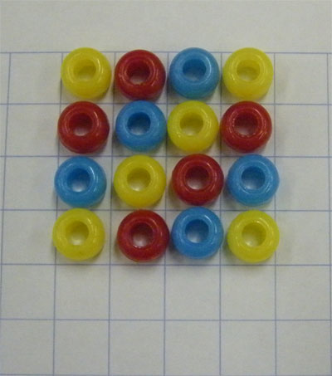

- Ask the students:
  - If you continued the pattern and used 28 beads, how many rows would you have on the loom? How many blue beads would you have on the loom?
  - If you had 35 beads, how many rows could you make? How many beads would be left over (i.e. remainder)
- (Extension) Ask the students:
  - Imagine if the beads were numbered:
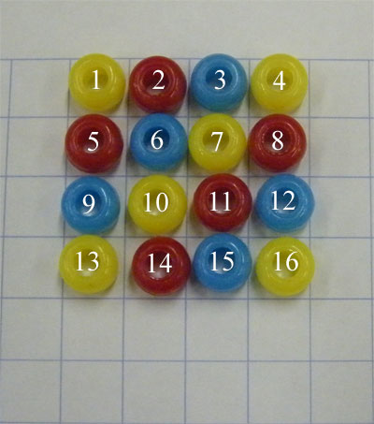
  - In what row is the bead number 30?
  - In what row is the bead number 74? What color is the bead?

